12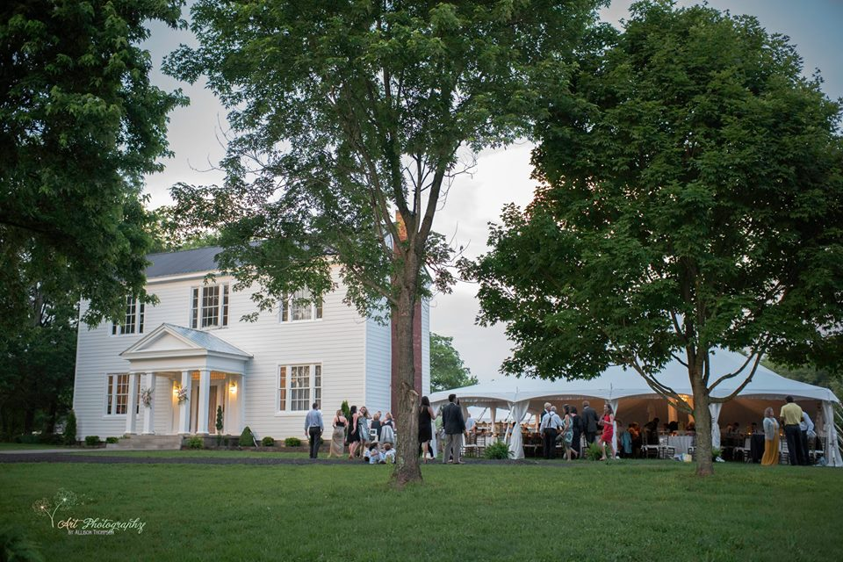
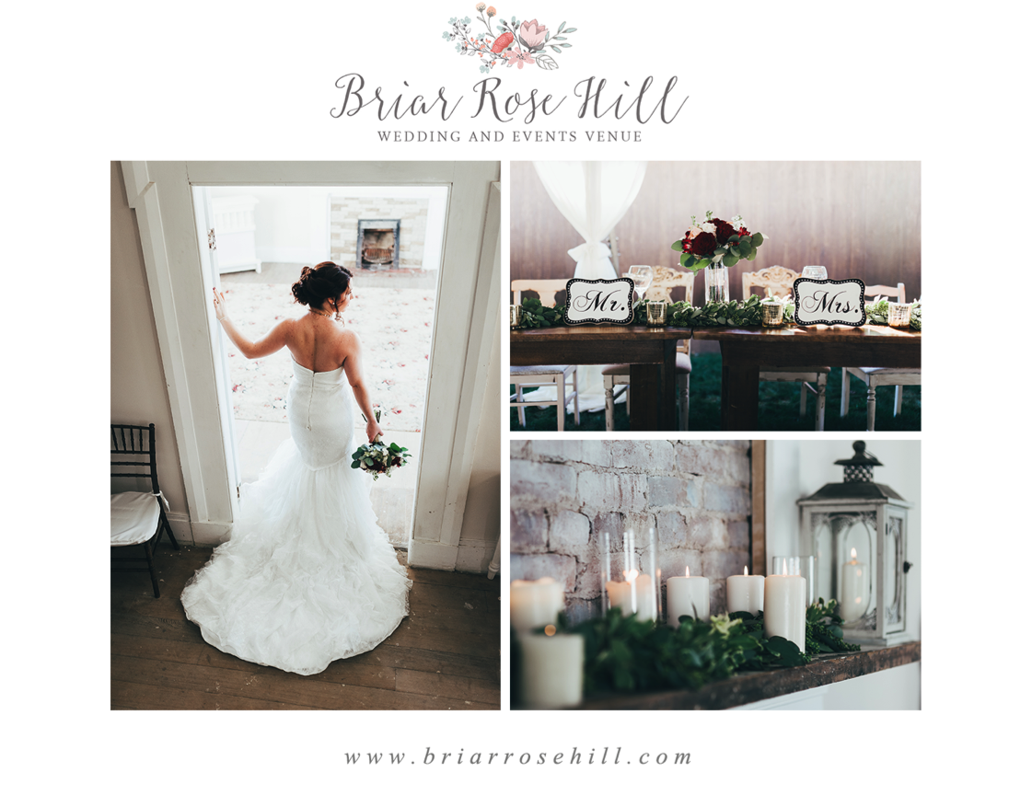
Wedding Bliss Package
All-inclusive package will include the following: 50-74 guests

**Venue rental for 9 hours
Use of Briar Rose Hill Plantation house, Bridal suite, and Grooms room
BRH event planner, designer, coordinator, staff member on duty the duration of the event
*Ceremony areas can be in front of Historic House or under our Bodock Tree
*Hanging lanterns in tree, draping, wood cross, arches, etc. to choose from

Full Service Catering (Buffet Style):
1 meat, 2 vegetables, salad, dinner rolls, sweet tea, unsweet tea, and lemonade, fruit tea, etc. (We do offer Mexican Menus and Italian Menus)
Full wait staff for clean up
Trash removal
Wedding Tent with draped poles only (Add full draping for additional cost).
Tables 60” round or 8” long
Cake Table (Many to choose from)
White garden chairs for ceremony
Chavari fruitwood chairs w/cushion for reception up to 74 guest
Linens for guest tables, sign in table, and gift table. (Ivory, Blush, or Navy Blue)
Linen napkins (You choose color)
Bridal Party Flowers include:
Bridal bouquet, 3 bridesmaid’s bouquets (Additional Bridesmaids Bouquets $35)
Groom and 3 groomsmen boutonniere (Additional boutonniere $10)
2-Mothers and 2-Fathers flowers
Flower girl petals
Ceremony area flowers (Design meeting included)
Reception table centerpieces (Design meeting included)
Cake flowers included
Professional DJ Services:
Ceremony sound system and microphone for officiant
Reception sound system, lighting, and emcee
Buttercream Wedding cake:
Cake stand (Different styles to choose from)
Tasting included and choice of flavors and design
1 –ABC licensed Bartender (Client provides beer and wine)

Carriage Barn for cocktail area, etc. Use of our Firepit area
Briar Rose Hill’s vintage props, décor full list available (Access to Pinterest room)
Full staff for set up of wedding ceremony and reception and clean up at end of night
Total Package - $12,900.00
Vintage Affair All-inclusive

All-inclusive package will include the following: 75-100 guests

Venue rental for 9 hours
Use of Briar Rose Hill Plantation house, Bridal suite, and Grooms room
BRH event planner, designer and coordinator
A BRH staff member on duty for the duration of the event
*Ceremony areas can be in front of Plantation House or under our Bodock Tree
*Hanging lanterns in tree, draping, mason jars, wood cross, arches, etc. to choose from

Full Service Catering (Buffet Style):
1 meat, 2 vegetables, salad, dinner rolls, sweet tea, unsweet tea, and lemonade, fruit tea, etc. (We do offer Mexican Menus and Italian Menus)
Full wait staff for clean up
Trash removal
Wedding Tent with draped poles only
Tables 60” round or 8” long
Cake Table (Many to choose from)
White garden chairs for ceremony
Chavari fruitwood chairs w/cushion for reception up to 100 guest
Linens for guest tables, sign in table, and gift table. (Ivory, Blush, or Navy Blue)
Linen napkins (You choose color)
Bridal Party Flowers include:
Bridal bouquet, 4 bridesmaid’s bouquets
Groom and 4 groomsmen boutonniere
2-Mothers and 2-Fathers flowers
Flower girl petals
Ceremony area flowers (Design meeting included)
Reception table centerpieces (Design meeting included)
Cake flowers included
Professional DJ Services:
Ceremony sound system and microphone for officiant
Reception sound system, lighting, and emcee
Buttercream Wedding cake:
Cake stand (Different styles to choose from)
Tasting included and choice of flavors and design
1 –ABC licensed Bartender (Client provides beer and wine)

Carriage Barn for cocktail area, etc.
Use of our Firepit area
Briar Rose Hill’s vintage props, décor full list available (Access to Pinterest room)
Full staff for set up of wedding ceremony and reception and clean up at end of night
Venue end time will be no later than 10:30pm
Total Package - $14,900.00
Simply Chic All-inclusive

All-inclusive package will include the following: 101-125 guests

Venue rental for 9 hours
Use of Briar Rose Hill Plantation House, Bridal suite, and Grooms room
BRH event designer and coordinator
A BRH staff member on duty for the duration of the event
*Ceremony areas can be in front of Plantation House or under our Bodock Tree
*Hanging lanterns in tree, draping, mason jars, wood cross, arches, etc. to choose from

Full Service Catering (Buffet Style):
1 meat, 2 vegetables, salad, dinner rolls, sweet tea, unsweet tea, and lemonade, fruit tea, etc. (We do offer Mexican Menus and Italian Menus)
1 – Appetizer for cocktail hour
Full wait staff for clean up
Trash removal
Wedding Tent with draped poles only
Tables 60” round or 8” long
Cake Table (Many to choose from)
White garden chairs for ceremony
Chavari fruitwood chairs w/cushion for reception up to 125 guest
Linens for guest tables, sign in table, and gift table. (Ivory, Blush, or Navy Blue)
Linen napkins (You choose color)
Bridal Party Flowers include:
Bridal bouquet, 4 bridesmaid’s bouquets
Groom and 4 groomsmen boutonniere
2-Mothers and 2-Fathers flowers
Flower girl petals
Ceremony area flowers (Design meeting included)
Reception table centerpieces (Design meeting included)
Cake flowers included
Professional DJ Services:
Ceremony sound system and microphone for officiant
Reception sound system, lighting, and emcee
Buttercream Wedding cake:
Cake stand (Different styles to choose from)
Tasting included and choice of flavors and design
1 –ABC licensed Bartender (Client provides beer and wine)

Use of our Firepit area
Carriage Barn for cocktail area, etc.
Briar Rose Hill’s vintage props and décor full list available (Access to Pintrest Room)
Full staff for set up of wedding ceremony and reception and clean up at end of night
Venue end time will be no later than 10:30pm
Total Package - $16,900.00
Love and Lace All-inclusive

All-inclusive package will include the following: 126-150 guests

Venue rental for 10 hours
Use of Briar Rose Hill Plantation House, Bridal suite, and Grooms room
BRH event designer and coordinator
A BRH staff member on duty for the duration of the event
*Ceremony areas can be in front of Plantation House or under our Bodock Tree
*Hanging lanterns in tree, draping, mason jars, wood cross, arches, etc. to choose from

Full Service Catering (Buffet Style):
1 meat, 2 vegetables, salad, dinner rolls, sweet tea, unsweet tea, and lemonade, fruit tea, etc. (Tasting and menu included) (We do offer Mexican Menus and Italian Menus)
1 – Appetizer for cocktail hour
Full wait staff for clean up
Trash removal
Wedding Tent with draped poles only
Tables 60” round or 8” long
Cake Table (Many to choose from)
White garden chairs for ceremony
Chavari fruitwood chairs w/cushion for reception up to 150 guests
Linens for guest tables, sign in table, and gift table. (Ivory, Blush, or Navy Blue)
Linen napkins (You choose color)
Bridal Party Flowers include:
Bridal bouquet, 4 bridesmaids bouquets
Groom and 4 groomsmen boutonniere
2-Mothers and 2-Fathers flowers
Flower girl petals
Ceremony area flowers (Design meeting included)
Reception table centerpieces (Design meeting included)
Cake flowers included
Professional DJ Services:
Ceremony sound system and microphone for officiant
Reception sound system, lighting, and emcee
Buttercream Wedding cake:
Cake stand (Different styles to choose from)
Tasting included and choice of flavors and design
2 –ABC licensed Bartender (Client provides beer and wine)

Use of our Firepit area
Carriage Barn for cocktail area, etc.
Briar Rose Hill’s vintage props and décor full list available (Access to Pintrest Room)
Full staff for set up of wedding ceremony and reception and clean up at end of night
Venue end time will be no later than 10:30pm
Total Package - $18,900.00
Southern Elegance All-inclusive

All-inclusive package will include the following: 150-175 guests

Venue rental for 11 hours
Use of Briar Rose Hill Plantation house, Bridal suite, and Grooms room
BRH event designer and coordinator
A BRH staff member on duty for the duration of the event
*Ceremony areas can be in front of Plantation House or under our Bodock Tree
*Hanging lanterns in tree, draping, mason jars, wood cross, arches, etc. to choose from

Full Service Catering (Buffet Style):
1 meat, 2 vegetables, salad, dinner rolls, sweet tea, unsweet tea, and lemonade, fruit tea, etc. (We do offer Mexican Menus and Italian Menus)
1 – Appetizer for cocktail hour
Full wait staff for clean up
Trash removal
Wedding Tent with draped poles only
Tables 60” round or 8” long
Cake Table (Many to choose from)
White garden chairs for ceremony
Chavari fruitwood chairs w/cushion for reception up to 175 guest
Linens for guest tables, sign in table, and gift table. (Ivory, Blush, or Navy Blue)
Linen napkins (You choose color)
Bridal Party Flowers include:
Bridal bouquet, 4 bridesmaid’s bouquets
Groom and 4 groomsmen boutonniere
2-Mothers and 2-Fathers flowers
Flower girl petals
Ceremony area flowers (Design meeting included)
Reception table centerpieces (Design meeting included)
Cake flowers included
Professional DJ Services:
Ceremony sound system and microphone for officiant
Reception sound system, lighting, and emcee
Buttercream Wedding cake:
Cake stand (Different styles to choose from)
Tasting included and choice of flavors and design
2 –ABC licensed Bartender (Client provides beer and wine)

Use of our Firepit area
Carriage Barn for cocktail area, etc.
Briar Rose Hill’s vintage props and décor full list available (Access to Pintrest Room)
Full staff for set up of wedding ceremony and reception and clean up at end of night
Venue end time will be no later than 10:30pm
Total Package - $21,900.00
Briar Rose Hill Requirements

**Wedding event insurance policy is required for all events. It can be purchased at https://www.wedsafe.com/Pages/home.aspx or https://www.markelinsurance.com
**Wedding Security is required. 5 hours - $350.00

Add on To Your Day with Something Fun! Inquiry about Pricing
Photo Booth, Cool Sparklers Boxes, Champagne Wall

Contact us to schedule a complimentary tour!

